Healthcare C-Suite Conversation with Ben Melson
November 30, 2018
12:30-1:30 PM
McNair Hall, Room 217

Health Care C-Suite Conversations aim to provide students with insights on challenges and opportunities that health care executives face as they lead their organizations. Please join us for an exclusive conversation with Ben Melson who will discuss his perspective on ‘Change Management.’

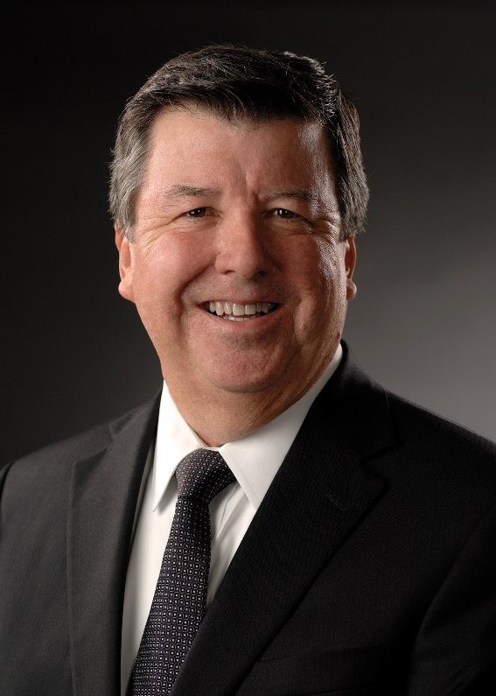
Ben Melson serves as Senior Vice President and Chief Financial Officer at The University of Texas MD Anderson Cancer Center. Prior to rejoining MD Anderson in May 2017, he was Executive Vice President and Chief Financial Officer at Texas Children’s Hospital for 12 years with responsibilities over a variety of functions, including financial services, information technology, the Medicaid HMO, revenue cycle, supply chain, government relations, the primary care physician group, facilities, security, risk management and the general counsel. Prior to joining Texas Children’s, Ben served six years at MD Anderson as Chief Financial Officer and 11 years at Hendrick Health System in Abilene, Texas, where he held a number of positions leading up to, and including, Chief Financial Officer.

As a Certified Public Accountant with 35 years of accounting and financial management experience (29 of which were served in the healthcare environment), Ben has a passion for building world-class, not-for-profit healthcare systems that create the highest possible levels of efficiency, quality, patient access and patient satisfaction.

Lunch will be served.

Space is limited and is first come first served. If you would like to attend, please RSVP via CampusGroups.

