Discover the Liu Idea Lab for Innovation & Entrepreneurship (Lilie)
Lilie is the home of entrepreneurship learning and venture development at Rice University. As you might have heard, we are also the #1 ranked graduate entrepreneurship program in the nation. Check out what Lilie has to offer below and schedule office hours with our Business Programs Manager, Kris Cuellar, to learn more.

Our resources available to MBA students fall under three main areas: experiential courses, co-curricular activities, and co-working space.
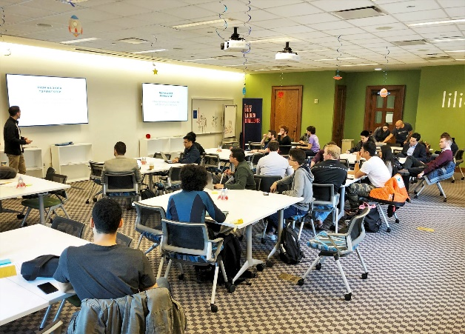
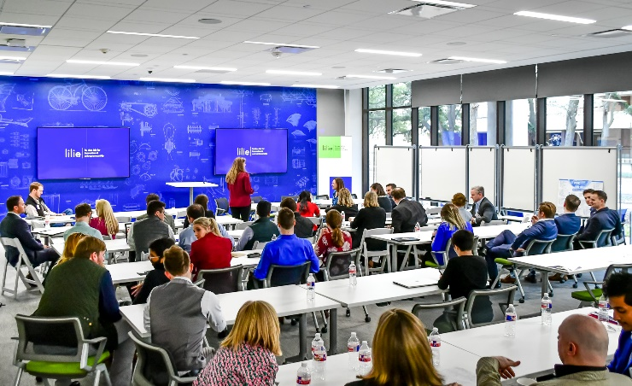
(Lilie co-working space in the Cambridge Office Building and McNair Hall)

Lilie, in conjunction with the Rice Business, offers 30+ entrepreneurship and innovation courses for all MBA programs as well as an Entrepreneurship Concentration for the full-time program. Want a preview of the entrepreneurship courses on offer? Check out our Fall 2021 Course Info Session recording.

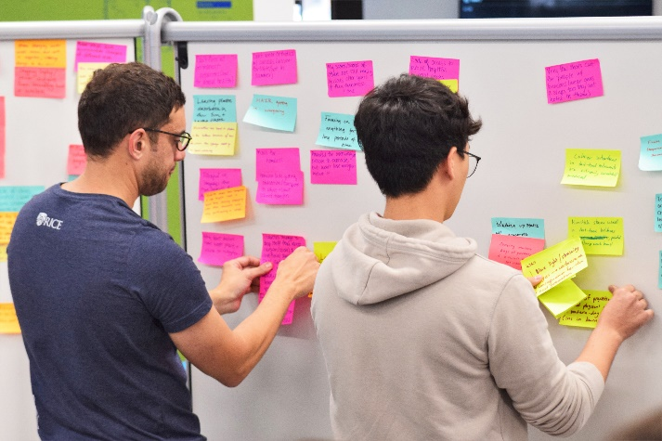

Students also have free access to events and activities, including:
- Office hours with entrepreneurs in residence
- Hands-on workshops, like Launchpad, to build an entrepreneurial mindset or launch a venture
- The Napier Rice Launch Challenge (NRLC), Rice’s annual internal startup competition worth $65k in equity-free seed funding
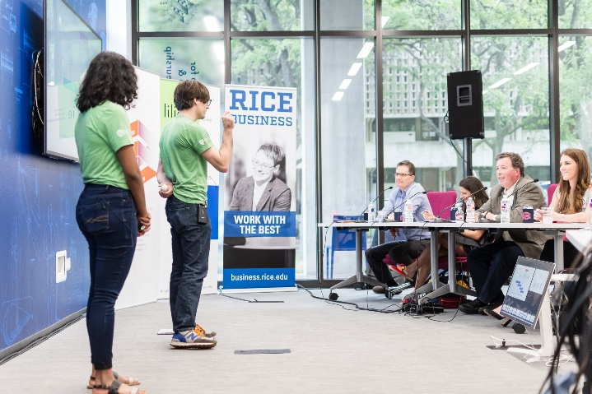

Rice and Lilie have produced entrepreneurs like Brian Armstrong of Coinbase, Brad Husick of NetGravity, Aamir Virani of Dropcam, and Robyn O’Brian of Do Good. Curious how Lilie can support your entrepreneurial mindset? Setup time to chat with Lilie’s Business Programs Manager, Kris Cuellar, to get one-on-one insight into how Lilie can help you accomplish your entrepreneurial goals.

Follow us on Facebook and Instagram.

